Combining Ideology & Indeterminacy: Dove Bradshaw’s first Dutch exhibition

30.12.2016 | REVIEW — Helen van Gorkum
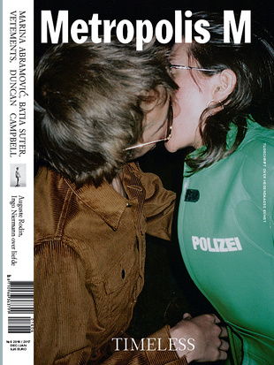
Issue no6
december - januari 2016
Timeless
The international platform Zone2Source located within Amsterdam’s Amstel park is currently hosting the Dove Bradshaw exhibition Spent. Both a retrospective (from the seventies onward) and a showcasing of her most recent work, it’s also her first display using almost sculpture only.
Concerned with atmospheric conditions, nature and culture, Bradshaw’s first Dutch exhibition fits in perfectly with the ideology of Zone2Source. Realizing workshops, discussions and exhibitions in three pavilions, Zone2Source examines the relationships between nature, technology and how these themes interact with 21st century society.
Bradshaw pioneered the use of indeterminacy in art focusing especially on the unpredictable effects of atmospheric conditions and time on a wide range of materials in the 1970s. Becoming a lifelong friend of John Cage in 1977, his works had already had a profound effect on her earliest work, especially his seminal book Silence: Lectures and Writings (1966) in which he included the famous Lecture on Nothing and wrote about how he incorporated chance and randomness into music, providing variation and multiplicity to any single score. Famously, Cage stated that any sound could constitute music (which is comparable to the way Duchamp stated that any object could constitute art with his ready-mades) and that it opened up the possibility to reflect on the world around you. Both Cage and Duchamp have had deep effect on Bradshaw’s works.
In 1971, Bradshaw, with the help of technicians at MIT, invented 2√0 ( The square root of zero), a glass water clock (also known as a klepsydra) inspiring the design on the symbol for infinity. When using it vertically it functions as a clock, much along the lines of an hourglass but using acetone instead of sand, and horizontally it functions as a level. However, the readings are erratic and continually changing, functioning within its own space and time. Incorporating this invention in her artistic oeuvre, this work is in considered to be one of the first pieces that led Bradshaw into the territory of indeterminacy in her work. At The Glass House pavilion, the work is not only on view in its original form, but also incorporated into a performance video Spacetime set to Cage’s work Ryoani, a duet for percussion and any other given instrument (here a flute) of which Cage gave her his first recording.
Choosing a wide range of materials to work with, Bradshaw is almost like a chemist choosing elements from the periodic chart and exposing them to each other providing different dimensions of time. Negative Irons II for example consists of a funnel hanging above a salt sculpture, eroding away slowly by dropping water on it periodically. The salt sculpture seems almost ephemeral when considering the Waterstone piece, where water erodes a limestone block at an even slower pace. Both sculptures invite viewers to attend to the functioning of seeing, over long-drawn-out periods of time. Hectic current day society seems to be countered by the meditative sounds of Cage in combination with the installations placed in the still glass pavilion.
However, this exhibition is by no means an escape from the current world. Bradshaw also offers the viewer political statements. Spent Bullets is a series of 3d printed blown up versions of the police bullets Bradshaw made in 1979. Referring to the violent nature of police bullets, Bradshaw made fired bullets or slugs into adornments, meant to be worn outside of the body, countering the initial destructive forces bullets have within the body and also prohibiting melting down and re-use. The bullets blown up to 30 times their size, as shown in Spent Bullet (2016), have been covered with different materials such as gold, car paint, bronze and rubber, the last similar to expanding bullets some current day American police forces use, increasing incapacitation and maximum harm to their intended targets. Bradshaw chooses to re-enter the work, and make something new by changing the function of the slugs.
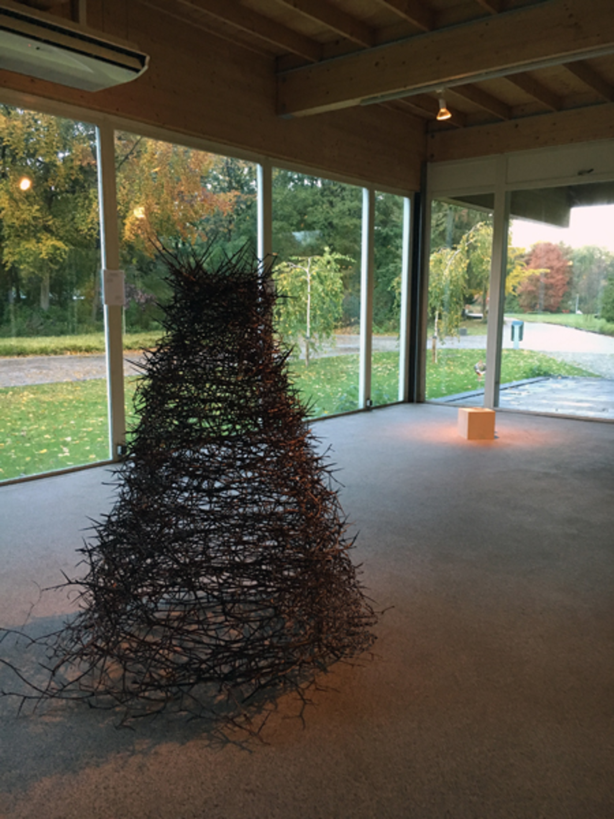
SLIDESHOW - CLICK ON IMAGE OR ARROW Home and Waterstone
The title of the exhibition refers to several sculptures in the exhibition at Zone2Source, of course the spent bullets, but also to the salt and limestone slowly eroding away over time, allowing viewers to absorb and experience the work at a slow paced level. Spent provides Bradshaw with a beautiful overview of her work, with sculptures interconnecting on different levels reacting to atmospheric and unpredictable effects on the materials, whilst simultaneously making uncomfortable statements about former and current society. Bradshaw’s work thus fits excellently in the program that Zone2Source hosts, exploring the relationships between art, technology and our natural environments and how they fit within our culture and society. Bradshaw’s Spent forms an outstanding stage
for exploring these themes from the vantage point of her art.

Dove Bradshaw at Het Glazen Huis, Amstelpark, Amsterdam, t/m 8.1.2017
Helen van Gorkum
student at the Vrije Universiteit Amsterdam

